Useful sites for code help:

https://www.raspberrypi.org/forums/

https://www.raspberrypi.org/help/

Sites to buy items from:

https://www.adafruit.com/

www.amazon.com

Camera Material:

Raspberry Pi Zero Computer Board (Wifi) with Headers (having the headers already attached is  not much more expensive and saves soldering time)

MicroSD card (16 GB) and Adapter (to plug into computer)

Micro USB Flash Drive (64 GB)

Battery and microUSB cord (linked battery not recommended for field, but useful for setup)  A second battery that can be drained and charged simultaneously (model currently used is no  longer available)

Real-time clock for Raspberry pi (make sure clock uses 3V power and not 5V)  PIR Sensor (compatible with raspberry pi) + extra female/female jumper wires 5MP Camera with case + appropriate connector

8MP Camera with case + appropriate connector

miniHDMI cord

MicroUSB extender (to plug in computer mouse, key board, and flash drive)  Key board

Computer mouse

Computer Display (or TV screen)

Personal computer/laptop

Installation Material:

Weather-proof container

Silicone sealant caulk

Desiccant packets (Or Cat Litter)

Drill + 1” diameter hole saw bit

Velcro adhesive strips or screws

Before Beginning:

All interaction with the raspberry pi (after SSH is enabled) is done through terminal on Mac or Git Bash on PC. Be sure your computer has this app already installed and ready to use.

Refer to this Raspberry Pi Diagram when referencing where to plug in modules and equipment.  The numbering of the header (in the red box) is also important when attaching the Real-time clock and the PIR sensor.

How to set up:

Set up RPi with components:

1. Plug MicroSD card into MicroSD port on RPi computer
2. Place camera in camera case according to directions, but without the stand (stand  pieces will be used to glue camera to container).

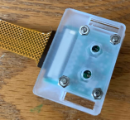

1. Attach camera to Camera Port
2. Attach PIR sensor to header:
   1. Attach a jumper wire from VCC on the PIR to pin #2 (5V) on the header of the  raspberry pi
   2. Attach a jumper wire from OUT on the PIR to pin #16 (GPIO23) on the header of  the raspberry pi
   3. Attach a jumper wire from GND on the PIR to pin #6 (Ground) on the header of  the raspberry pi
3. Setup the Real-time clock according to directions specific to your RTC module or  according to our directions (these directions are for an RTC model DS3231):
   1. Plug in the real time clock:
   2. Plug into pins 1, 3, 5, 7, & 9

1. Plug in power cable to Power Port

Prepare the model SD Card:

1. Download Raspberry Pi Imager (https://www.raspberrypi.com/software/)
2. Plug the SD card into your computer and use the RPi Imager to burn Raspian onto the SD card. Click the gear to set up the card with ssh already enabled and wifi set up. For Karp Lab setup, the settings should be the following:

Note: ask Katie Lauck for the password for the wifi network and to set the correct password for the pi itself.

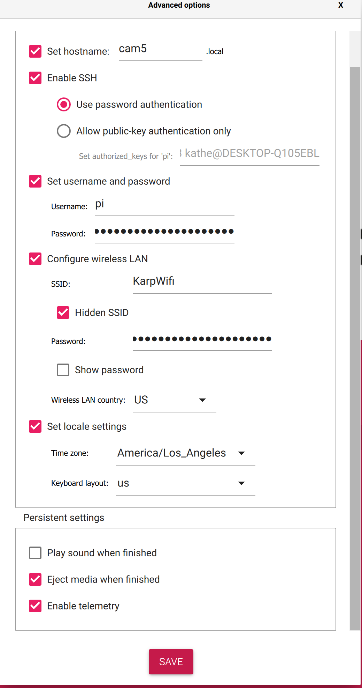

1. Plug the card into a fully outfitted RPi camera as described above.
2. Plug the camera into power; wait for it to boot up and then ssh into it using ssh pi@cam5 (or whatever hostname you used in step 2).
3. Change some settings: sudo raspi-config
   1. Enable camera: Interfacing options > enable legacy camera > yes
   2. enable i2c: interfacing options > enable i2c> yes
   3. Select finish, then yes to reboot.
4. ssh back in, then copy diurnal.py to /home/pi and diurnal.service to /etc/systemd/system. The best way to do so is using scp – Google how to use it if you’re unfamiliar – the command will depend on where the files are on your computer.
5. Create directories for the script:

sudo mkdir /mnt/usb

sudo mkdir /mnt/usb/videos

1. Update rpi and install packages (run each line separately and wait until each one finishes  to enter the next):

sudo apt-get update

sudo apt-get dist-upgrade

sudo apt-get install -y gpac

If “Do you want to continue” pops up, type “y” and enter

* 1. Run:
     1. sudo nano /etc/modules (screenshot)
     2. Add rtc-ds3231 at the end of the list of modules

* + 1. Save and exit (more details) Test to make sure the clock is attached:

sudo apt-get install i2c-tools

pip install smbus2

sudo i2cdetect -y 1

You should see a “68” in the table

* + 1. Run:

sudo nano /etc/rc.local

Add to code in line before “exit 0:

echo ds3231 0x68 > /sys/class/i2c-adapter/i2c-1/new_device

hwclock -s

Save and exit (more details)

sudo reboot

* + 1. Once reboot is complete, SSH back into the camera

Run:

sudo i2cdetect -y 1

You should see “UU” where “68” was

Make sure the computer is reading the correct time:

date

* + 1. Run code and make sure everything is working properly

sudo python diurnal.py

Let it run for ~5 minutes to ensure no problems (trigger motion a few times)  ● Control+C to escape program (may have to press this a few times)

1. Update the permissions of the service file and reload the daemon:

sudo chmod 644 /etc/systemd/system/diurnal.service

sudo systemctl daemon-reload

sudo systemctl enable diurnal.service

sudo reboot

1. Remove flash drive and check on computer to make sure videos appear (see  below for removing and viewing files
2. Replace flash drive in the rpi
3. Download and install: on Windows, <https://sourceforge.net/projects/win32diskimager/>. Use the “Read” function of this utility to create a bootable disk image of the
4. On Mac, follow this guide: <https://howchoo.com/pi/create-a-backup-image-of-your-raspberry-pi-sd-card-in-mac-osx>

Keep the resulting file for burning onto other SD cards.

To remove and view files:

Because the videos are taken in h264 files, we have to convert them to mp4 files to view.

1. Download “convert.sh” file
2. Make a folder specifically for video conversion on your computer (Desktop/h264_videos)
3. Remove flashdrive from rpi and plug into computer
4. Copy the files from the flash drive into folder created
5. [More detailed instructions]
6. Make sure all files were converted to mp4 in the folder
7. Remove files from the usb stick

When loading onto a new SD card:

1. Use either Disk Imager (Windows) or dd (Mac) to write the image created using this guide to an SD card. Plug the SD card into a built-out camera and plug into power.
2. ssh into the camera using ssh pi@[hostname] and then change the hostname:

sudo raspi-config

Choose network options, then hostname, then enter the camera’s name in the hostname field. Select ok, finish, then reboot. Make sure the camera lights up, and wave your hand in front of the camera a few times. Check that it recorded the videos, then format the SD card as described below.

Formatting SD card while ssh connected to camera:

1. sudo systemctl stop diurnal
2. sudo fdisk -l
3. sudo umount /dev/sda1 (or the name of the sd card in results of sudo fdisk -l)
4. sudo mkfs.exfat /dev/sda1 (or the name of the sd card in results of sudo fdisk -l)

Installation in box

This is the method we have used, but there may be other, better ways of installation.

1. Using the 1” hole saw drill bit, drill a hole in the lid of the container (large circle in photo  below)
2. Using a ⅜”-½” drill bit (depending on the size of the battery cord) drill a hole in the short  side of the container (small circle in photo below)
3. Using silicone sealant, glue Raspberry Pi board to base of container under large hole in  lid with Power Port facing small hole in side of container.
4. Using silicone sealant, glue camera to lid (with lens facing the lid) using a leg from the  stand as a middle piece between camera and lid (make sure protective film on lens is  removed before gluing).
5. Remove plastic dome from PIR sensor base. Using sealant or hot glue, glue this dome in  the large hole drilled in lid. Seal any cracks. Place PIR base back with the plastic dome.
6. Make sure PIR and camera are still connected properly to the computer  7. Plug battery cord into raspberry pi with cord going out small hole in side. Seal around  the cord with silicone sealant
7. Glue a piece of tin foil over the camera and PIR sensor (the Wifi signals from the RPi  interfere with the PIR sensor).
8. Place 5-10 desiccant packets in container. (Cat littler also works)
9. Place strips of velcro adhesive on lid of container (black rectangles in photo below)
10. Peel off backing from other side of adhesive and press against the nest box, making sure  the camera and PIR are hanging over the front of the nest box at the opening.
11. Pull off camera from Velcro on nest box and reinforce the velcro strips on the nest box  by screwing them in.
12. Repeat this process with the battery as well.